

**AFRICA NAZARENE UNIVERSITY**

**COMPUTER AND INFORMATION TECHNOLOGY DEPARTMENT**

## PEACE TAILORING ONLINE SHOPPING STORE

**BY**

**Sylvia Yvonne Onserio**

**17SO3ADIT018**

**Supervisor**

**Mr. Ambrose Njeru**

**December 2018**

Submitted in partial fulfillment of the requirements of the Diploma in Information Technology

# DECLARATION

This project is my original work and to the best of my knowledge and has not been presented for any other award in any university.

NAME: Onserio Sylvia Yvonne

REGISTRATION NUMBER: 17s03adit018

SIGNATURE:

DATE:

This project has been submitted as partial fulfilment of the requirements for the award of a Diploma Information Technology at Africa Nazarene University and has been done with the guidance of my supervisor.

NAME: Ambrose Njeru

SIGNATURE:

DATE:

# ABSTRACT

The purpose of this project is to come up with a system that will provide a platform that will enable shoppers to connect with designers and be able to sell their products and also connect with motorists to facilitate the transportation of the clothing brought by the shopper. This is by enabling shoppers to find clothes for all gender under one store, enable designers to sell their products and earn a living and enable motorists to offer transport service and also earn a living. At the end of the day the shopper’s satisfaction is the main area of concern

All this was to be achieved by developing a system that will enable all the users to access to the system wherever they are regardless of the device that they are using. this would be achieved by use of MY SQL, HTML, CSS, BOOTSTRAP, JAVASCRIPT. This system will use web-based technologies since web is cross platform. The technologies of development will be MySQL database, HTML, CSS, JavaScript, PHP and Bootstrap for responsive web pages.

# Contents

PEACE TAILORING ONLINE SHOPPING STORE 1

DECLARATION 2

ABSTRACT 3

Contents 4

List of tables 7

List of figures 7

ACKNOWLEGDEMENT 8

LIST OF ABBREVIATIONS 9

1. CHAPTER ONE 10

1.1 Introduction 10

1.2 Problem Statement 10

1.3 Objectives 11

1.3 System development objectives 11

1.4 Scope of the project 11

1.5 Research Questions 11

1.6 Assumptions and Limitations 12

1.7 Justification 12

2. Literature review 13

2.1 Introduction 13

2.2 Overview of online shopping stores 13

2.3 Preview of existing system 14

2.3.1 Mimi Kenya 14

2.3.2 Jumia Online Stores Kenya 14

2.3.4 Mama Mike’s Online store. 14

2.4 Overall weakness of the visible in all the three stores 14

3. METHODLOGY 16

3.1 RESEARCH METHODOLOGY 16

3.1.1 Research Design 16

3.1.2 Target population and Sampling frame 16

3.1.3 Data collection methods and instruments 16

3.1.4 Data analysis 16

3.2 SYSTEM DEVELOPMENT METHODOLOGY 17

3.2.1 Requirement Specifications 17

3.2.2 System analysis and design 18

3.2.3 System coding 18

3.2.4 System testing and debugging 19

3.2.5 System deployment and Maintenance 19

3.2.6 Resources required. 19

4. System design 20

4.1 Use case diagram 20

4.2 Context diagram 22

4.3 Level 0 Data Flow Diagram: All system processes 23

4.4 Level 1 Data Flow Diagram: Payments 24

4.5 Database Design and Entity Relationship Diagram 25

5. Implementation and testing 27

5.1 Resources required 27

5.1.1 Hardware resources 27

5.1.2 Software resources 27

5.2 System testing and debugging 28

5.2.1 System testing 28

5.2.2 Test cases 29

5.3 System deployment and maintenance 30

6.1 Achievements 31

6.2 Constraints 31

6.3 Recommendation 31

6.4 Conclusion 31

References 32

Appendices 33

Appendix A: Letter of Introduction 33

Appendix B: Questionnaire 34

Appendix C: Sample Interview Questions 37

Appendix D: Budget 38

Appendix E: Work Plan (Gannt Chart) 39

Appendix F: Sample Codes 40

Appendix G: System Screenshots 42

# List of tables

Table 1 Use Case Table 21

Table 2 Test Case Table 30

# List of figures

Figure 1Use Case diagram 20

Figure 2Context Diagram 22

Figure 3 Level 0 DFD 23

Figure 4 Level 1 DFD 24

Figure 5 Entity Relationship Diagram 25

Figure 6 Database Diagram 26

# ACKNOWLEGDEMENT

I am grateful to God for the good health and strength He has granted me to learn and for providing priceless people who without their effort and collaboration, this project wouldn’t be a success.

I would like to thank the following people for their contribution to my inspiration, knowledge and other help in working through this project.

1. My parents to make me believe I can do it.
2. My supervisor Mr. Ambrose Njeru for his support and guidance even where I thought I could not make it.
3. Job Okello who supported me and contributed a lot to the successful progress of this project.

# LIST OF ABBREVIATIONS

* DFD – Data Flow Diagram
* SQL – Structured Query Language
* CSS – Cascading Style Sheets
* API – Application Programming Interface

# 1. CHAPTER ONE

## 1.1 Introduction

Online Peace Tailoring shopping store was developed for the smooth ordering and buying of any type of fashion design at affordable price in the city of Nairobi and other places one would want to order. My research enabled me recognize and define the problem in the current online stores. After an information gathering process from several online shopping stores, I saw that the business indeed needed one to create a system that would enable customers whether female or male when shopping online to be able to put their personal details online so as not encounter a problem in finding best design of any occasion and save time when one is being delivered. After a close analysis of samples collected during the problem definition stage, I found out that the buying and ordering of fashion design clothes in online Peace Tailoring is readily available in the city due to its affordability to many customers and owners due to it meeting human expectations .Online Peace Tailoring shopping store was developed to ensure that there is maximum efficiency of any type of design the customer wants .The e-commerce website will indeed help the Online Peace Tailoring shopping store and the staff members to manage and steer the business functionality and transactions to realize its maximum potential in addition to its competence in the Online shopping stores business field. (Uk, 2018)

## 1.2 Problem Statement

Clothing is one of the basic human needs, and since time immemorial buying cloths has always been an activity that was confined within markets and shopping stores. This therefore meant that to acquire a cloth one had to leave home head to the market for the purpose if shopping. the modern individual however is a person who would handle more than one job just to keep up with the harsh economic times. As a result, such individuals are deprived of time to carry out shopping. despite all of this technology has however enabled such individuals to carry out shopping from the comfort of their homes. This is enabled by stores that took on online shopping as a business model.

This however did not solve most of the problems that exist in the current market. This is due to the fact that the most of the current online shopping stores lack variety and customization. This can be owed to the fact that the stores have a fixed set of designers that supply them with their clothing merchandise. As a result, most of the local designers who are equally and even more talented are left to only sell their merchandise to a limited network of shoppers i.e. those within their locality.

To solve this issue a platform should therefore be created to allow the local designers to sign up and get an opportunity to widen the customer network and earn a living. This platform should also take advantage of the individuals within the transport sector who will also get an income earning opportunity by being able to offer their shipping services at a fee. At the end of it all we will have a satisfied customer due to having more options to choose from and designers and transporters who get to earn a living for the services that they offer.

### 1.3 Objectives

## 1.3 System development objectives

1. Creating a system that will enable users to login as either shoppers, Designers and transporters.
2. A system that will enable shoppers to connect to designers within a similar geographical so as to save on time and cost of services between both parties.
3. Creating a system that enables shoppers to evaluate the products and designers prior to paying for the services.
4. Designers should be notified once they have booked for the design of a shoppers clothing.
5. Create a system that will enable transport agent to ship products to the shoppers with ease of navigation.

## 1.4 Scope of the project

This project will focus on helping the online Peace Tailoring shopping store to sell their designs online to everyone regardless of whether male or female by creating a system that would enable them put their personal details such as Name, Location, Duration of hiring, his or her size and type of material to be used because by doing so they will reduce time wastage by ordering them at the same time and when delivering no extra charges due it being return because of the size is large or small.

## 1.5 Research Questions

1. How to enable customers to be able to give their personal details online such as Name, Location, Duration of hiring, his or her size and type of material to be used so as to minimize the time wasted on looking for a design.
2. How customers and visitors can view for the designs they want online in any given time before they give an order

## 1.6 Assumptions and Limitations

Online Peace Tailoring clothing store assumes that:

1. Everybody has internet access.
2. Everybody has good computer and technology skills.
3. Everybody has a good communication device.

## 1.7 Justification

With the current technological advancement and explosion of the internet globally, Kenya is of the countries that is enjoying the benefits of such advancements with above 60% of its population having access to the internet and other technologies that seem to make the world a global village. This therefore means that at least 6 out of every 10 Kenyans have access to the internet services. This is further boosted with the mobile phone penetration with over 80% of the population having access to mobile phones and other computing devices. Having this knowledge in mind we can therefore observer that a web-based shopping would be a perfect fit as a technology to deploy our online store. This is due to the fact that website can be accessed across all devices and across all technologies used to deploy mobile services. This there means that whether an individual is on IOS, Android, Linux and Windows device or using a smartphone, tablet, desktop or laptop computer, the individual will still be able to gain access to the shopping services. (Anon., 2018)

# 2. Literature review

## 2.1 Introduction

This chapter aims at taking a look at the current online shopping that mainly focus on clothing as their main product. The problem statement highlighted in chapter on will be looked into in more detail with respect the existing stores selling cloths using the various online platforms available. The chapter will consider the factors affecting customers as they make their purchases from these stores. The various issues facing the online stores will be analyzed and be used to point out the various issues the online stores. The knowledge acquired from this chapter will then be used to form the basis of strength and uniqueness for the online stores that is to be developed in this project. This will also enable the business to have better operational model that will ensure a higher return on investment and within a short period of time.

## 2.2 Overview of online shopping stores

In today’s world the average adult is most an employee who spends a better part of his day at the work premises. This therefore leaves such an individual with very little time to carry out other personal activities such as shopping. Thanks to the evolution of technology and the rise of the internet, this individual is now able to carry out shopping for most of the daily items that they might need in their household from the comfort of their homes. This comes even more handy in the busy holiday season where the individual only is saved from the trouble of waiting in long queues and having to bother with the opening and closing of the stores since online stores are open 24 hours a day. Another interesting thing about online clothing stores is that the customer is able to find a huge variety of items from the same store, somethings that would have require them to move from shop to shop if they were shopping manually. In the next sub section, we will a look at the existing online stores in the country such Mimi Kenya, Jumia Kenya and Mama Mike’s Online store.

## 2.3 Preview of existing system

### 2.3.1 Mimi Kenya

Mimi online store’s offices are located in Nakumatt road, Kahawa Nairobi and First floor, Avenue House. Mimi influences the fashion Kenyan ladies take especially the middle class where the targeted average dresses is about 3000.Delivery is done well as long as you wait their delivery days. Presenter Julie Gichuru centered her business plan around the growing culture of online trade and commerce that is already fast developing where online offers increased accessibility to markets than a shop in a mall. It also has classy, sophisticated and trendy fashion for everyone especially Kenyan ladies. It is also one of the Kenyans leading selling of clothes through her dressing attracts and her general popularity. This effectively makes her store get return on investment within a short period of time where she gets ten compliments and dressing suggestions on her social media after every Sunday live. It’s getting down comes where Mimi starts settling on high cost of rental properties in Kenya means an online that customers would have to pay much more for venture for their merchandise and this may make ladies who are below middle not to shop there. Also, when one is delivered a dress, she may find it is not of her size. (Anon., 2018)

### 2.3.2 Jumia Online Stores Kenya

Jumia offline stores are in Nairobi CBD Emperor Plaza, Kenyatta Avn. Opp. GPO. It is an open business-to-consumer platform enabling business to reach Africa’s vast and growing consumer market. It has established itself as the destination for quality, branded products, catering and to an increasingly sophisticated African consumer(s). Their growth is largely influenced by the professionalism and carrier growth of their employees which they have backed with test practices and effective knowledge transfer from across the globe. It also provides opportunities for staff to grow across different roles in the organizations. Their employees have access to a comprehensive health plan which includes, their spouse and children and competitive salary package. When shipping in Jumia shopping store, making payment means accepting delivery. Therefore, it is not possible to open products bearing manufacturers seal, reject and send them back with the same driver if the product is oversize or smaller .it can only be returned if you haven’t opened and allow the return policy. For the ones overseas or anyone who wants to return, one will incur an extra shipping fee of ksh.100 when returning. (Anon., 2018)

### 2.3.4 Mama Mike’s Online store.

Mama Mike is also another one of the upcoming online stores. It deals mostly with adult clothing hence narrowing down their target market to mostly adults between the ages of 30-50years. This is due to the fact they focus mostly focus in the urban ware franchise, which has managed to attracted the customers within that given age bracket. Just like Jumia and Mimi, the store has a lot of similarities when it comes to identifying a dress is and get it is a simple as just logging into the site and picking your dress and waiting for the delivery. (Anon., 2018)

## 2.4 Overall weakness of the visible in all the three stores

Despite the above-mentioned stores facilitating selling of clothing at the consumers comfort there are still a lot of issues that are still left without being catered for. This include:

1. In the instance a customer gets a delivery with the wrong measurements, some shops have policies that make purchase returns almost impossible.
2. There is lack of personal touch between the customers and the designers(tailors) hence limiting customers to only taking the ready-made clothes with the only thing that they can customize being the body size.
3. Some stores focus on imports and hence the period between shopping and the receipt of an order being longer than expected due to all the importation protocols.
4. Due to imports and the need to have a wide market base the companies spend more in establishing their business and initial costs and hence they end up having attires that are too expensive for the average consumer who will then have no other option but to resolve to using the old shopping methods.
5. Some stores also lack originality by not bringing designers on board as they insist on being middle-men in the businesses.
6. Most stores also insist on having a fixed number of designers and transporting agents handling their cloth production and shipping locking outside a large number of talented individuals who would have been very instrumental when it came to production and shipping functions.

# 3. METHODLOGY

## 3.1 RESEARCH METHODOLOGY

This is the manner in which a problem to be solved through the creation of a new system will be identified and given a logical sequence of steps that will contribute towards the solving of the problem at hand. In our case the internet will serve a great purpose in identifying the existent systems and their shortcomings which will play also enable the creation of an enhanced system. In the instances where further clarity is needed the owners of the existing systems will be contacted for more information.

### 3.1.1 Research Design

This is the general nature of the method used to carry out research for the development of a new system. In this case the knowledge of existing systems will be quite essential in mapping out the how the new system will be built so as to make the system more efficient than the existing ones.

In the case of the Peace Tailoring stores the questionnaire was the main method that was used in the collection of data. The questionnaire was designed based on the knowledge of existing systems that are currently carrying out online retail of cloths to shoppers. The questionnaire was distributed to the respondents with an aim of identifying the functioning of the existing systems, the weaknesses and also the profiling of the shoppers themselves.

### 3.1.2 Target population and Sampling frame

The questionnaires were distributed to 64 respondents within different locations including the campus. The respondents were chosen based on their availability and their willingness to answer the questions given to them. This exercise was in accordance with the quantitative data collection procedure. Most of the respondents were also chosen based on their age in that there all had legal consent to carry out purchase shopping from stores that offered online retail services. This therefore meant that their ages were ranging from the ages of 18 years to 70 years of age.

### 3.1.3 Data collection methods and instruments

The most suitable method of data collection in the research were the use of questionnaires. Through the questionnaire a survey of the target population on their interaction with online shopping services was carried out. The questionnaire was divided into two parts. The first part was focused upon the users themselves. This helped in collecting demographic information such as age and gender of the respondents for the purpose of population profiling. The second part of the questionnaire was focused on the existing similar systems carrying out online retail services. The questions on this part of the questionnaire mainly focused on the respondent’s experience while shopping online for clothes. This also gave data that enabled the looking into the system and be able to spot the areas of weakness in the systems and come up with a better system.

### 3.1.4 Data analysis

After the data collection was done through the questionnaire was done, an analysis was carried and the following results were obtained according to the questions asked in the questionnaire. This analysis was carried out using the descriptive statistical analysis for the preparation of the averages using graphs and frequencies.

1. **Demographic analysis**

According to the demographic collected from the respondents using the questionnaires it was found that 55% of the respondents were male while 45% of the recipients were female. The majority of the respondents making up 64% were also found to be in the age bracket of 21 – 25 years of age. This also went in hand in hand with the fact that the 58% of the respondents were college students. The respondents were also found to be reluctant in shopping online as 50% of them shopped online while the remaining portion preferred to shop online for goods at least once in a month. Despite all that a majority of the respondents still gave the online shops a preference over the normal physical shopping.

1. **Existing system analysis**

When it came to the experience with the existing system the respondents still gave online shops a preference to the traditional shopping methods. The respondents also placed the quality of clothing as the main reason as to why they would opt to buy clothes from online stores as shown by 45% of their responses. Though the respondents still liked shopping for clothes online they still preferred to pay for the purchase cloth items upon delivery as opposed paying online before the product is delivered as shown by 87% of their responses. The respondents also wanted their purchased items to be delivered at their homes instead of the agreed pick stations set up by the stores as seen in 64% of the responses. Smartphones and laptops were also found to be the main prefers device for carrying out shopping due to portability and the ability to access online store applications and websites as shown through 66% of the responses. When it came to spending most of the respondents were found to have spent between ksh. 1000 – 5000 while shopping online for clothes as shown by 71% of their responses. These respondents also stated that their shopping while online was not out of the spur of the moment as is commonly believed but planned as shown by 71% of their responses. Despite having so much confidence in online stores 43% of the respondents would still try and makes comparison of their purchase with local offline clothing stores. When it came to taste and customizations the respondents 71% of the respondents still preferred to have customized clothing before purchasing them.

## 3.2 SYSTEM DEVELOPMENT METHODOLOGY

The system will be developed using the Waterfall Project Management model. The model will contain the following steps:

1. Requirement specifications
2. System analysis and design
3. System Implementation/coding
4. Testing and Debugging
5. Deployment and Maintenance

### 3.2.1 Requirement Specifications

**Functional requirements**

The system should be able to meet the following functional requirements:

1. The system should enable users to create accounts and be able to carry out their roles i.e. shoppers, Designers and transporters.
2. Designers should have the ability to also create their own account s and be able to display their merchandise.
3. The system should have a mechanism of communication between the shoppers and the designers.
4. The system should enable the shoppers to make payments for their service and also enable the payment of the designers and the transport facilitators upon the completion of each purchase.
5. The system should enable the client to view the list of available designers and their products.
6. The system should enable the shoppers to be able to keep track of their purchases while designers keep track of their sales.
7. The system should also have a mechanism of enhancing the navigational capabilities of the transport facilitators during the delivery of the purchased goods.

**Non-Functional Requirements**

The system should be able to meet the following non-functional requirements:

1. **Usability –** the system should have a user-friendly interface for ease of use.
2. **Security –** the system should be able to guarantee the safety of user data and security of each transaction.
3. **Reliability –** the system should be accessed all 24/7 with less technical requirements
4. **Flexibility –** the system should be accessible from any device regardless of the operating system and hardware architecture.
5. **Accuracy –** the system should be accurate in terms of data inputs and outputs for all users.

### 3.2.2 System analysis and design

The system will be broken down into two parts:

1. **The front end** – this will be the website which the users will be interacting with. It will be composed of several webpages based on the user’s activity in the system.
2. **The back end** – this will be the part of the system that will be made up of the system’s database and be responsible for carrying out data processing.

The design of the system in terms of data flow will be represented using data flow diagrams and entity relationship diagrams.

### 3.2.3 System coding

The implementation and coding of the system will be done using the following software:

1. WAMP Server – a software that enables the local hosting of the website during the development period.
2. Sublime Text – this is an advanced text editor with support for languages such a HTML, CSS, JavaScript, PHP, MySQL and many more.
3. Google Chrome browser – this will be the testing browser for the system.
4. Windows 10 operating system – the operating system upon which the system will be deployed and tested during development phase.

The following scripting languages will be used:

1. **HTML** and **CSS** – language for the front-end design of the system’s webpages
2. **JavaScript** – language for enhancing interactivity and data entry validation on the webpages.
3. **PHP** – the language for connecting the webpages to the database of the system.
4. **MySQL** – the language implementing the system’s database.

### 3.2.4 System testing and debugging

After completing the development of the system testing will be done in order to ensure that the system functions as expected. The testing will be done in the following terms:

1. **Unit testing** – This will involve testing each module in the system for any error during performance.
2. **Integration testing** – this will involve the testing of how different in the system work when combined to work on a given task in the system.
3. **Data validation and exception testing** – this will be done by entering both correct and incorrect data input into the system so as to see how the different modules will process data even in exceptional situations.
4. **System testing** – when all the above stages of testing are completed the whole of the system will be tested before being deployed.

### 3.2.5 System deployment and Maintenance

After completion of the testing and debugging phase of the system development life cycle, the system will then be deployed to a few users for testing for a given period of time so as to get the overall response on the system from users. The feedback from the users will then be used to tweak the system further in order to fit the overall user liking.

### 3.2.6 Resources required.

The hardware resources required for the development of the system will include:

a. Desktop computer or laptop having 4 GB of RAM, 300 GB of storage space 1 GB graphics memory.

The software resources required for the development of the system will include:

1. Windows 10 operating system
2. Sublime Text 3 text editor
3. Google Chrome Browser
4. WAMP server software

# System design

## 4.1 Use case diagram

Use case models give high level description of system by outlining the interaction between the users of the system and the system itself. This enables the modelling of the systems functionalities to the system requirements collected during the requirements stage of the system development life cycle. Use case diagrams use cases which are the various functionalities of the system and the actors who are the entities that interact with the various uses cases found in the system.

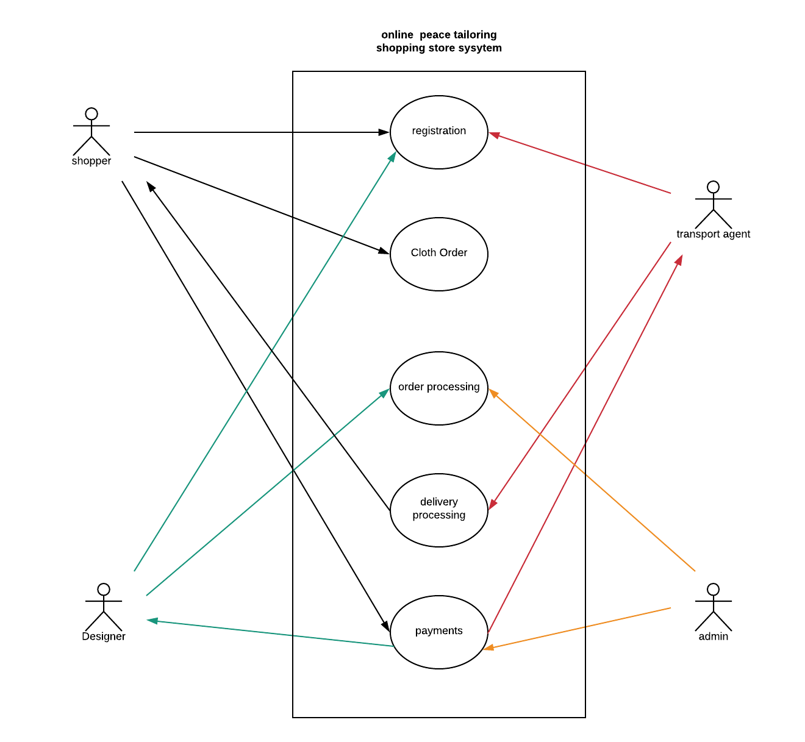

Figure 1Use Case diagram

The table below shows the Use Case diagram description with respective actors.

|  |  |  |
| --- | --- | --- |
| **Use Case** | **Actor** | **Description** |
| Registration | Shopper, designer and transport agent | This enables all the users to create account in the system and carry out their respective roles in the system. |
| Cloth order | Shopper | This allows the shopper to views the available clothing and therefore make an order based on his or her preferences. |
| Order processing | Designer, system admin | This enables the designers to accept the order from the shopper and produce a final product as per the shopper’s requirements. |
| Delivery processing | Transport agent | This allows the transport agent to receive the completed cloth orders and deliver them to the shopper’s premises. |
| Payments | System admin, Shopper, designer and transport agent | This allows both the designers and the transport agents to get payment once an order has been completed. It also allows the shoppers to get refunds on return of the purchases if they were not satisfied. |

Table 1 Use Case Table

## 4.2 Context diagram

This a diagram showing the main process that the system performs. The diagram gives the main entities of the system and the data flow into and out of the system. The rest of the component processes of the system are not displayed but hidden within the main process which is the process 0.

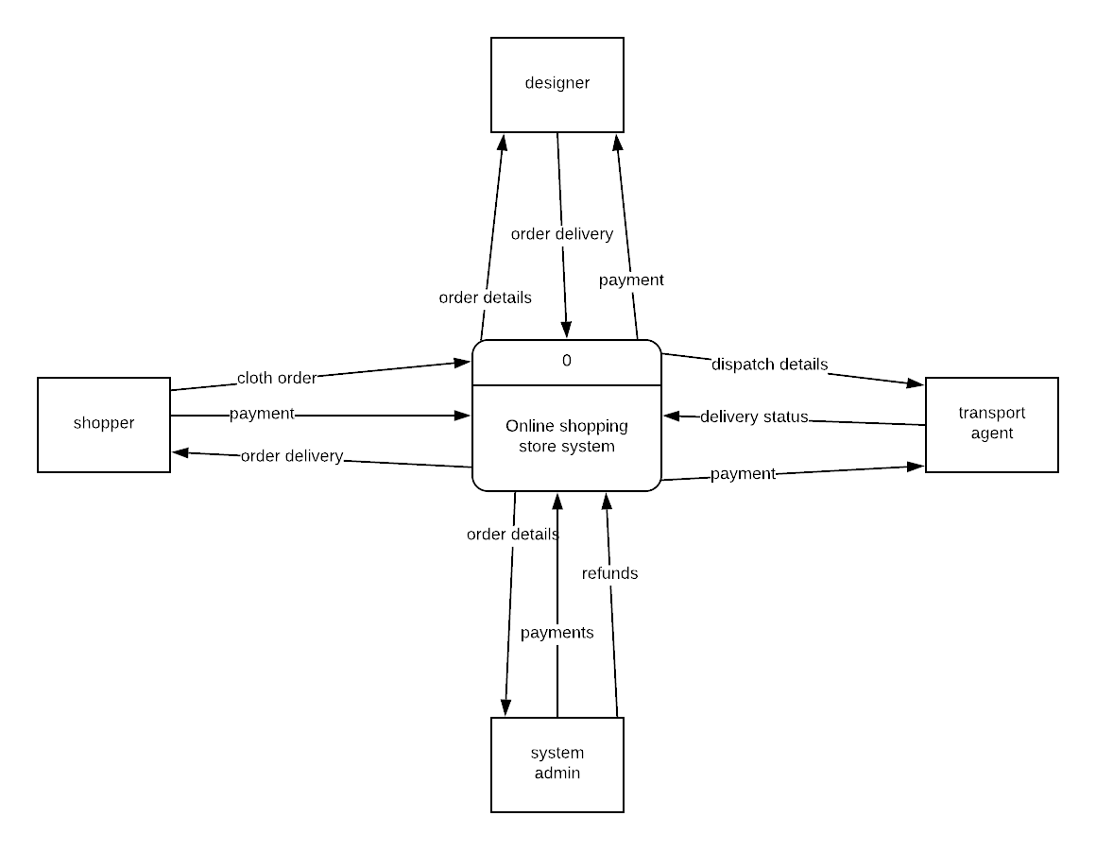

Figure 2Context Diagram

## 4.3 Level 0 Data Flow Diagram: All system processes

This is dataflow diagram that explodes all the major processes of the system associated with all the data flows and data stores in the system as the users of the system get to interact with the system.

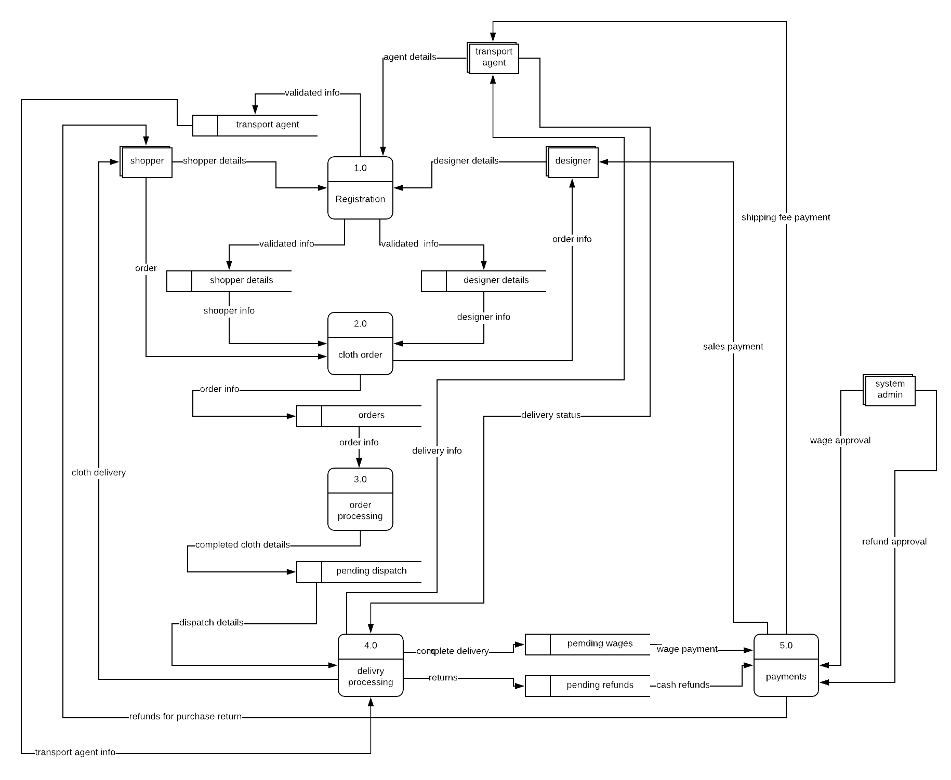

Figure 3 Level 0 DFD

Level 0 DFD

## 4.4 Level 1 Data Flow Diagram: Payments

This is a diagram that explores one of the processes in the system as shown in the level 0 DFD at a more detailed manner. This just like the rest gives the entities involved, data flow, data stores and process after the breakdown of the of the process. This diagram explores the payment process from the level 0 data flow diagram.

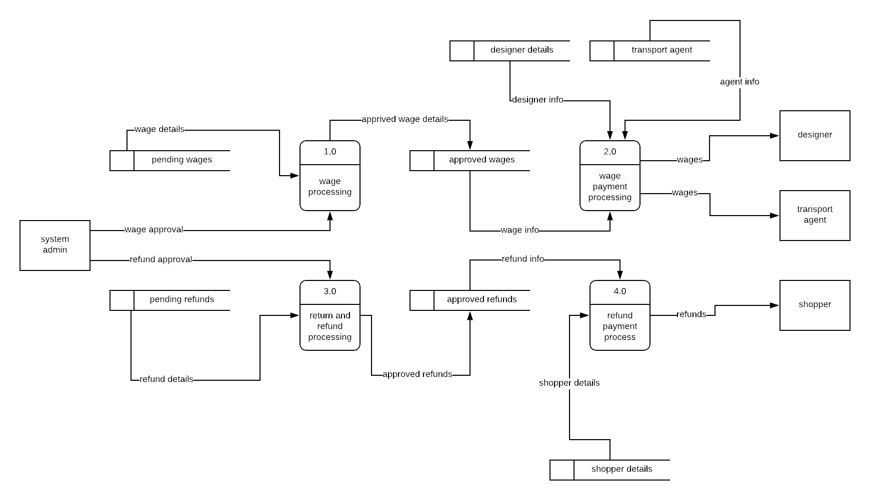

Figure 4 Level 1 DFD

## 4.5 Database Design and Entity Relationship Diagram

**Entity relationship diagram**

An entity relationship diagram (ERD) shows the relationships of entity sets stored in a database. An entity in this context is an object, a component of data. An entity set is a collection of similar entities. These entities can have attributes that define its properties.

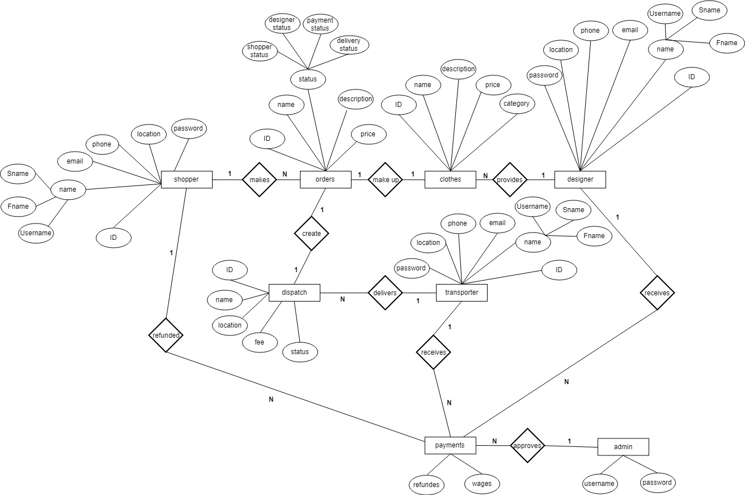

Figure 5 Entity Relationship Diagram

**Entity Relationship Diagram**

**Database design**

This is diagram that gives a diagrammatic representation of the system’s database. When the users of the system get to interact with the data entered or generated by the system is stored in the systems database with their relationship being as depicted in the figure below.

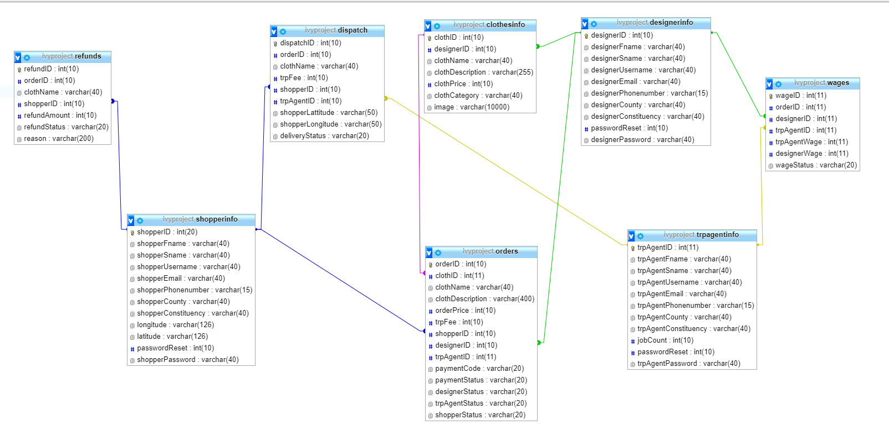

Figure 6 Database Diagram

# 5. Implementation and testing

## **5.1 Resources required**

The system will be developed using the following hardware and software resources.

### **5.1.1 Hardware resources**

The computer that will be used to develop the system will have to meet the following requirements:

1. 4 Gigabytes of RAM.
2. 300Gigabytes of storage space.
3. 1 Gigabytes of dedicated graphics card memory.
4. 2Hz CPU processing speed.

### 5.1.2 Software resources

The following software tools and scripting languages will be used to develop the system to completion:

1. **WAMP server-**this will be the localhost software for the system.
2. **PHP storm-** this is the integrated development environment that supports HTML, CSS, JavaScript and PHP scripting languages.
3. **MYSQL-** this will be the software where the system’s database will reside.
4. **Google chrome browser-**this will be the testing browser for the system.
5. **Window 10 operating system-** the operating system upon which the system will be deployed.
6. **HTML and CSS-** languages for the front-end design of the system’s webpages.
7. **JavaScript-** language for enhancing interactivity and data entry validation on the webpages.
8. **PHP-** the language for connecting the webpages to the database of the system.
9. **MySQL-** the language implementing the system’s database.
10. **Google maps API-** application programming interface for aiding the navigation capabilities during the communication of the systems users

## 5.2 System testing and debugging

### 5.2.1 System testing

After completing the development of the system, testing will be done in order to ensure that the system function as expected. The testing will be done in the following terms:

1. **Unit testing-** This will involve testing each module in the system for any error during performance.
2. **Integration testing-** This will involve the testing of how different the system will work when combined to work on a given task in the system.
3. **Data validation and expectation testing-** This will be done by entering both correct and incorrect data input into the system so as to see how the different modules will process data even in exceptional situations.
4. **System testing-** When all the above stages of testing are completed, the system will be tested before being deployed.

### 5.2.2 Test cases

Test cases identify and communicate the conditions that will be implemented in test and are necessary to verify successful and acceptable implementation of the system’s requirements.

|  |  |  |  |  |  |
| --- | --- | --- | --- | --- | --- |
| **Test case** | **Module (Process)** | **Description** | **input** | **Expected results** | **Actual output** |
| 1 | Registration | This enables the shopper, designer and transport to create individual accounts. | Enter valid personal details. | Success message and redirection to login page. | Success message and redirection to login page. |
| Enter invalid personal details. | Error message displayed and prompt re-entry of personal details. | Error message displayed and prompt re-entry of personal details. |
| 2 | Cloth ordering | This enables the shopper to evaluate cloths from different designers then deciding on which one to buy. | Selecting a cloth and adding to cart | If cloth is in stock it will be added to cart and await payment. | If cloth is in stock it will be added to cart and await payment. |
| 3 | Order processing | This enables the designer to work on the order placed by the shopper | Designer enters confirmation for the orders cloth. | Success message with update of on the designer’s confirmation and emailing the shopper on the successful completion of the cloth order. | Success message with update of on the designer’s confirmation and emailing the shopper on the successful completion of the cloth order. |
| Designer cancels the cloth order. | The order will be deleted and the shopper be notified of the cancellation. | The order will be deleted and the shopper be notified of the cancellation. |
| 4 | Order delivery | This enables the transport agent to be transport the clothing package once the designer has finished preparing the order | The transport agent enters the delivery confirmation of the to the shopper | Shopper notified of the delivery of the cloth order and also confirms the delivery by him/herself. | Shopper notified of the delivery of the cloth order and also confirms the delivery by him/herself. |
|  | The transport agent cancels the delivery or does not give the confirmation of the delivery. | The shopper does not get delivery confirmation and therefore has to wait until order is delivered or contacts the admin. | The shopper does not get delivery confirmation and therefore has to wait until order is delivered or contacts the admin. |
| 5 | Payment | This enables either the payment of the designer and the transport agent on the completion of an order by the shopper. A refund on the event a failed order. | Confirmation of order delivery by the shopper. Confirmation of dispatch delivery by the transport agent. Confirmation of cloth finished order preparation by the designer | If all the parties confirm the completion of the order then the designer and the transporter will be paid in terms of wages and transport fees. | If all the parties confirm the completion of the order then the designer and the transporter will be paid in terms of wages and transport fees. |
| If any or all of the parties don’t confirm the completion of the order then the shopper will be refunded for the failed delivery | Shopper will be refunded for failed delivery. | Shopper will be refunded for failed delivery. |

Table 2 Test Case Table

## 5.3 System deployment and maintenance

After completion of the debugging phase of the system development life cycle, the system will then be deployed to a few users for testing for a given period of time so as to get the overall response on the system from users. The feedback from the users will then be used to tweak the system further in order to fit the overall user liking.

**6. Conclusion and Recommendation**

## 6.1 Achievements

The successful completion of the project produced a working system based on the previously listed design specification and conceptual model. The working model was able to meet the following user requirements:

1. Users were able to create their account according to their roles in the system i.e. shoppers, designers and transporters.
2. Shoppers were able to evaluate cloths and make purchases from a wide collection of designers
3. Designers were able to put out their designed clothes and accessed shoppers from all over the country
4. All users of the system were able to be notified by email through out the order processing period.
5. The shoppers were able to make purchases and the designers were able to be paid for their services.
6. The system enabled the shoppers to be refunded incase an order was not completed successfully.

## 6.2 Constraints

Despite the successful completion of the project and the production of a working system, a few challenges were met and this hindered the full implementation of some functionalities of the system. This challenge includes:

* The acquisition of an M-pesa paybill account number was hindered by the high cost hence the payment process in the system had to be simulated through the system’s database.

## 6.3 Recommendation

This web application can further be reviewed further and be developed into mobile app for optimization.

## 6.4 Conclusion

The main aim of this project was to develop a web-based system that would allow the shoppers to be able to book buy clothes and assure that the designers and motorists obtain standard salary and get to earn a living. This project has been successfully completed and will go a long way changing the current operations in regards to the online shopping for clothes.

# References

Anon., 2018. *How many Internet users are in Kenya?.* [Online]   
Available at: https://www.businessdailyafrica.com/corporate/tech/How-many-Internet-users-are-in-Kenya/4258474-4259072-htn83lz/index.html

Anon., 2018. *Jumia.* [Online]   
Available at: www.jumia.co.ke

Anon., 2018. *Mama Mike's online shop.* [Online]   
Available at: www.mamamike.co.ke

Anon., 2018. *Mimi Kenya.* [Online]   
Available at: 1.1.1 www.mimi.co.ke

Mannic, 2018. *AI.* [Online]   
Available at: http://www.aiai.ed.ac.uk/links/cbr.html

Uk, I., 2018. *100 best online clothes shops.* [Online]   
Available at: https://www.independent.co.uk/extras/indybest/fashion-beauty/womens-clothing/best-online-clothes-shops-women-men-luxury-budget-vintage-discount-8092852.html  
[Accessed 19 September 2018].

# Appendices

## Appendix A: Letter of Introduction

|  |
| --- |
| Sylvia Yvonne Onserio  Africa Nazarene University  P. Box 53067 – 00200  Nairobi  Kenya  20th November 2018  Ambrose Njeru  African Nazarene University  P. Box 53067 – 00200  Nairobi, Kenya  Dear Sir,  **RE: PROJECT INTRODUCTION LETTER**  I am hope that you are well. I am writing with an aim of introduce you to my project which is based on online shopping on clothing. This project will be aimed at producing a platform that will enable shoppers to connect with designers and be able to purchase cloths online and also have the ability to get the goods delivered to them by transport agents.  This platform will be aimed to bridge the gap that is normally set by the online stores who have a fixed set of designers and transport agents. This is because the platform will enable the shoppers, transporters and designers to freely sign up and be able to become members of a community of that enables the buying and selling of clothes across the country. My project at the very end of it will therefore improve the shoppers experience while shopping online and also create income earning opportunity for the transporters and the designers.  I look forward to your consideration.  Kind Regards  Sylvia Yvonne Onserio |

## Appendix B: Questionnaire

|  |
| --- |
| **PEACE TAILORING ONLINE SHOPPING STORE**  **QUESTIONAIRE**  Hello this is a conducting a survey based on the Peace Tailoring online shopping store platform. Kindly go through the questions and give your answer by ticking the appropriate circle. Feel free to ask for assistance/clarity at any given point.  **Part A: People**   1. What is your gender?  * Male * Female  1. What age bracket do you belong to?  * 16 – 20 years * 21 – 25 years * 26 – 30 years * 31 – 35 years * 36 – 40 years * 41 – 45 yeas * 46 – 50 years * Above 50 years  1. What is your current employment status?  * Unemployed * Student * Full-time employee * Part-time employee * Self employed * Retired   **Part B: Context**   1. How did come to know of Peace Tailoring Online Shopping store?  * Through friends * Online invitations * Newspaper advertisements * Links on social media platforms i.e. Facebook, WhatsApp, Twitter  1. How often do you buy goods online?  * Once a week * Multiple times in a week * Once in a month * Multiple times in a month * Rarely  1. Rate your preference of online shopping to traditional physical shopping?  * 1 * 2 * 3 * 4 * 5  1. Which of the following Influenced your decision above?  * Product price comparison * Quality of products * Large variety of products * Large pool of suppliers * Mode of payment * Time factor * Mode of product delivery * Ability to keep up to date with market trends   **Part C: Activities**   1. Where do you usually take inspiration for new purchase?  * Family * Friends * Celebrities * Fashion magazines * Events * Trends on social media  1. Which of the following will influence your decision while shopping for clothes from online store?  * Product pricing * Product quality * Product branding * Mode of payment * Mode of delivery * Color * Material * Style * Comfort  1. Which mode of payment do you find more convenient while shopping online?  * Online payment (before delivery) * Pay on delivery  1. Which mode of delivery would you prefer for a product you just purchased online?  * Home delivery * Pick-up stations   12. Which platforms give you optimized user experience while shopping online?   * Store websites * Smartphone application  1. Which device gives you the most enjoyable shopping experience on Jumia?  * Smartphones * Tablets * Laptops & desktops computers  1. What are the major challenges that you face or have faced after purchasing clothing from an online? 2. Briefly describe any additional features and improvements that you would like stores to make so as to improve your shopping experience   **Part D: Technologies**   1. How much would you spend to purchase a clothing from an online store  * Below ksh.100 * Ksh.100-500 * Ksh.500-1000 * Ksh.1000-5000 * Above Ksh.5000  1. Are your purchases usually planned or spur of the moment?  * Planned * Spur of the moment * Either  1. When purchasing a new item, do you buy a matching outfit item?  * Sometimes * Quite often * All the time * Not often * No never  1. Who do you mainly shop with?  * Alone * Family and friends * Partner * Colleagues * Choice 5  1. When shopping for clothes, do you:  * Decide to go in due to the window display/adverts * Try new shops * Search beforehand for information and then visit the right store for me * Go to shops where there are special offers * Others  1. Do you prefer any customizations on the clothes that you purchase?  * Yes * No  1. Rate your experience from shopping for clothes from online stores.  * 1 * 2 * 3 * 4 * 5   Kindly sign in the given slot below:  **Thank you for your time.** |

## Appendix C: Sample Interview Questions

## Appendix D: Budget

|  |  |  |  |  |  |  |  |  |  |  |  |  |  |  |  |  |  |  |  |  |  |  |  |  |  |  |  |  |  |  |  |  |  |  |  |  |
| --- | --- | --- | --- | --- | --- | --- | --- | --- | --- | --- | --- | --- | --- | --- | --- | --- | --- | --- | --- | --- | --- | --- | --- | --- | --- | --- | --- | --- | --- | --- | --- | --- | --- | --- | --- | --- |
| **Project Budget**  **Ivy Designs**   |  |  |  |  | | --- | --- | --- | --- | | Budget | | Actual | Under (Over) | | Total | 10,000 | 8000 | 2000 |   Project Name: **Peace Tailoring online shopping store**  Start date: **10th September 2018**   |  |  |  |  | | --- | --- | --- | --- | | **Serial** | **Task(resource)** | **Quantity** | **Cost (ksh.)** | | 1 | Transport | 3 Months | 3800 | | 2 | Internet | 3 Months | 3000 | | 3 | Laptop | 1 | Free | | 4 | Printing Cost | - | 1200 | | 5 | Development Software | 5 | Free | | 6 | Miscellaneous | - | Free | |

## Appendix E: Work Plan (Gannt Chart)

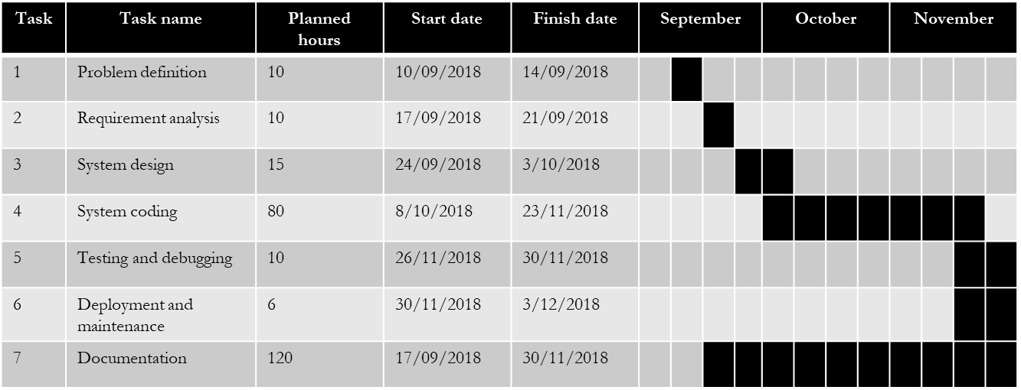

## Appendix F: Sample Codes

shopperRegistration.php

|  |
| --- |
| <?php  //gives variable for creating the connection  $servername = "localhost";  $username = "root";  $password = "";  $dbname = "ivyproject";  // Create connection  $conn = new mysqli($servername, $username, $password, $dbname);  // Check whether the connection was successful  if ($conn->connect_error) {  die("Connection failed: " . $conn->connect_error);  }else  echo "Connected successfully";  //check whether each data item was picked from the form successfully  if (isset($_POST['fName'])) {  $shopperfName = trim($_POST["fName"]);  }  if (isset($_POST['sName'])) {  $shoppersName = trim($_POST["sName"]);  }  if (isset($_POST['username'])) {  $shopperusername = trim($_POST["username"]);  }  if (isset($_POST['email'])) {  $shopperemail = trim($_POST["email"]);  }  if (isset($_POST['phone'])) {  $shopperPhonenumber = trim($_POST["phone"]);  }  if (isset($_POST['county'])) {  $shopperCounty = trim($_POST["county"]);  }  if (isset($_POST['constituency'])) {  $shopperConstituency = trim($_POST["constituency"]);  }  if (isset($_POST['latitude'])) {  $latitude = trim($_POST["latitude"]);  }  if (isset($_POST['longitude'])) {  $longitude = trim($_POST["longitude"]);  }  if (isset($_POST['password'])) {  $shopperPassword = md5($_POST["password"]);  }  $sql = "INSERT INTO shopperinfo (shopperfName, shoppersName,shopperusername, shopperemail, shopperPhonenumber, shopperCounty, shopperConstituency, latitude, longitude, shopperPassword)  VALUES ('$shopperfName', '$shoppersName', '$shopperusername', '$shopperemail', '$shopperPhonenumber', '$shopperCounty', '$shopperConstituency', $latitude, $longitude, '$shopperPassword')";  if (mysqli_query($conn, $sql)) {  echo "New record created successfully";  header('Location: ../html/shopperSuccess.html');  } else {  echo "Error: " . $sql . "<br>" . mysqli_error($conn);  }  //closes the connection with the database  mysqli_close($conn);  ?> |

## Appendix G: System Screenshots

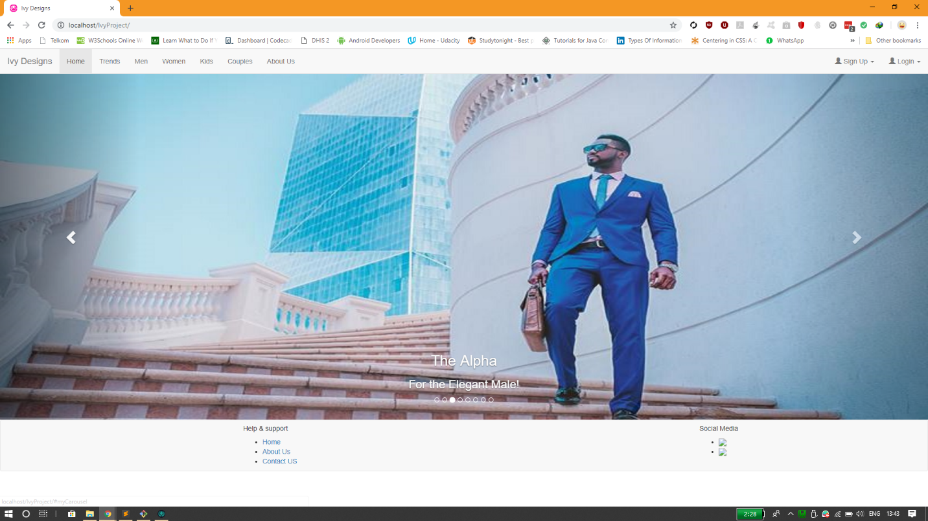

Home page

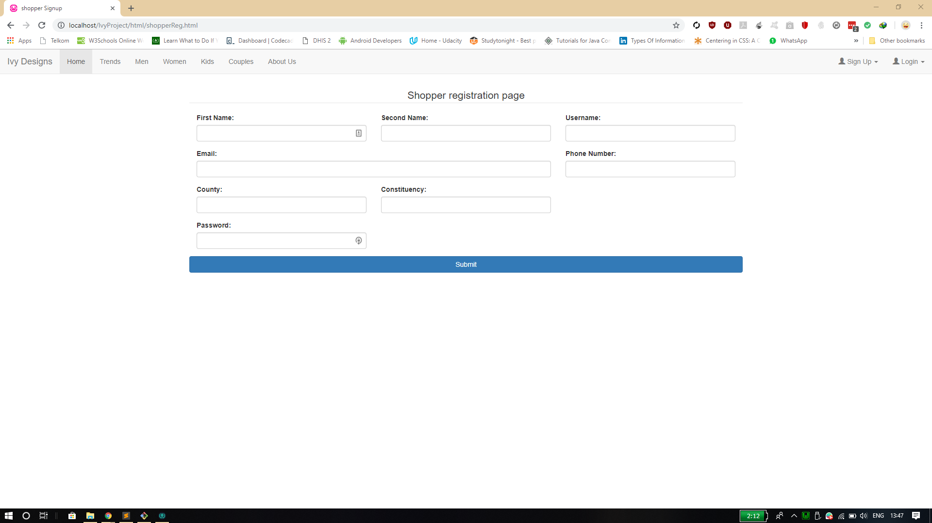

Registration page

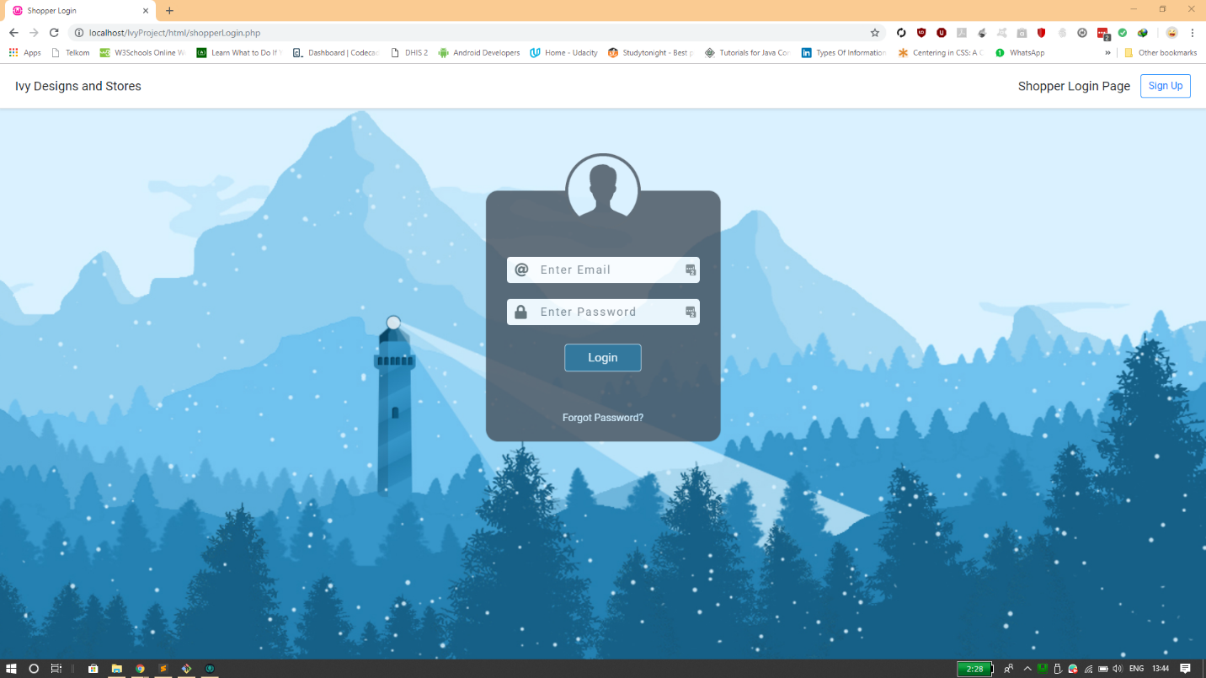

Login page

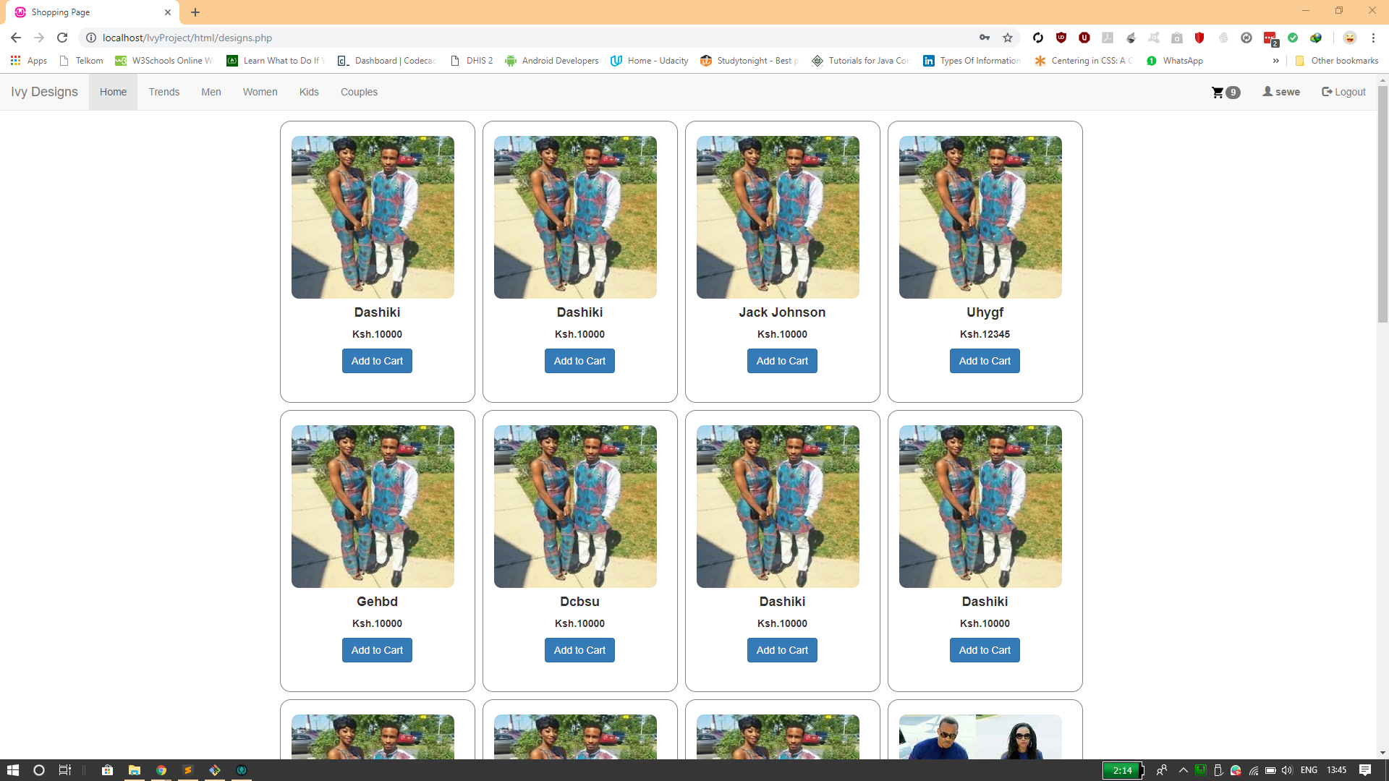

Shopping page

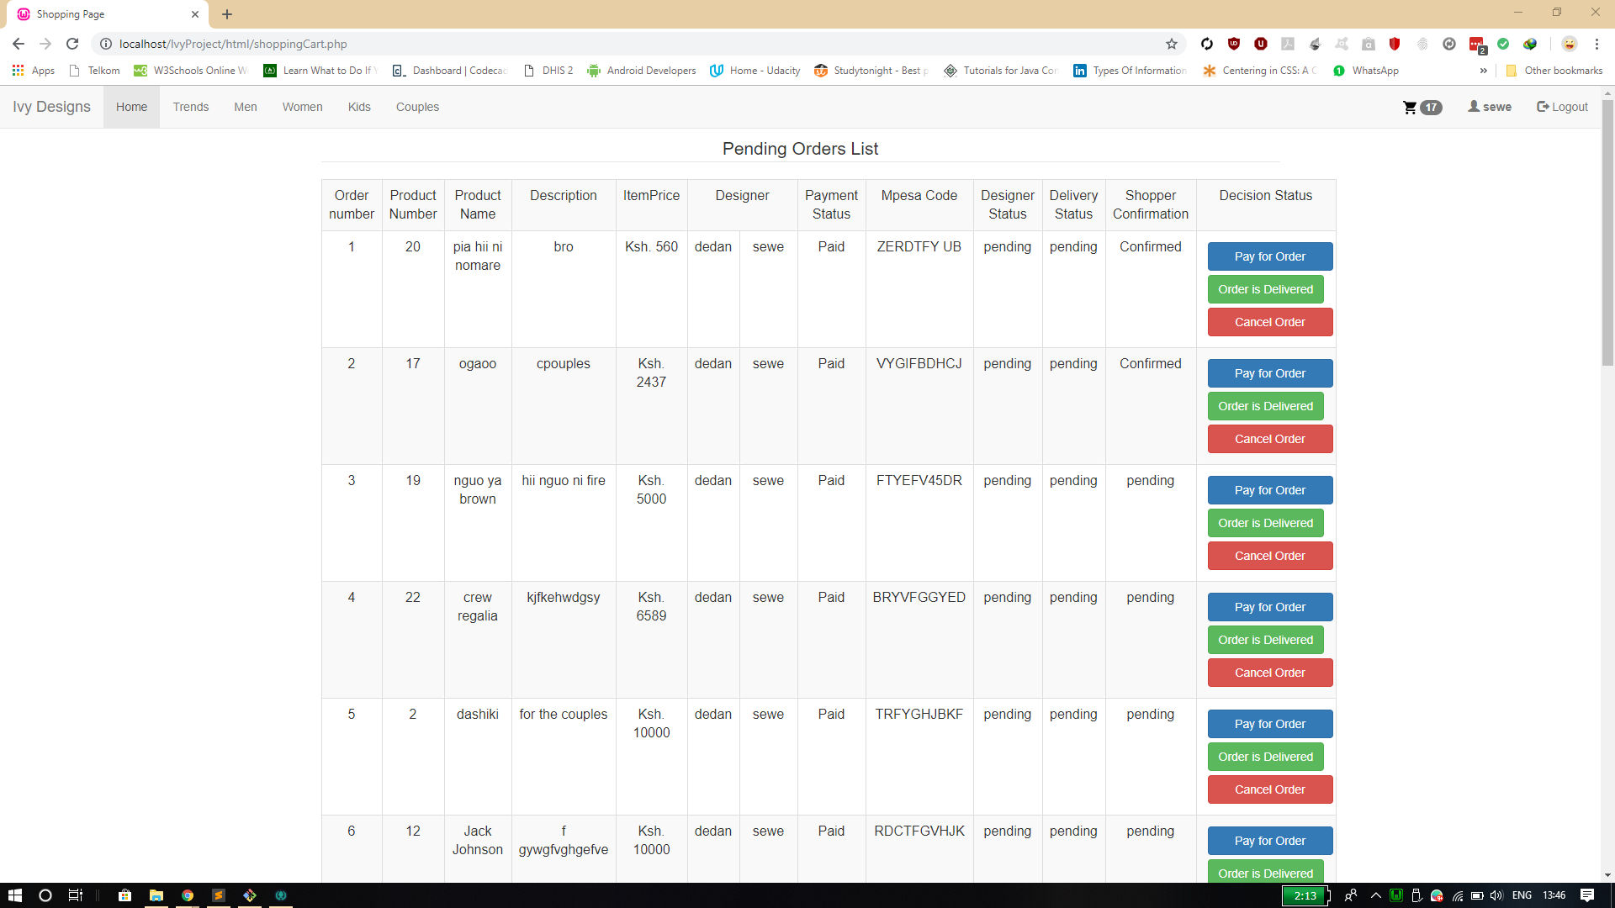

Shopping cart

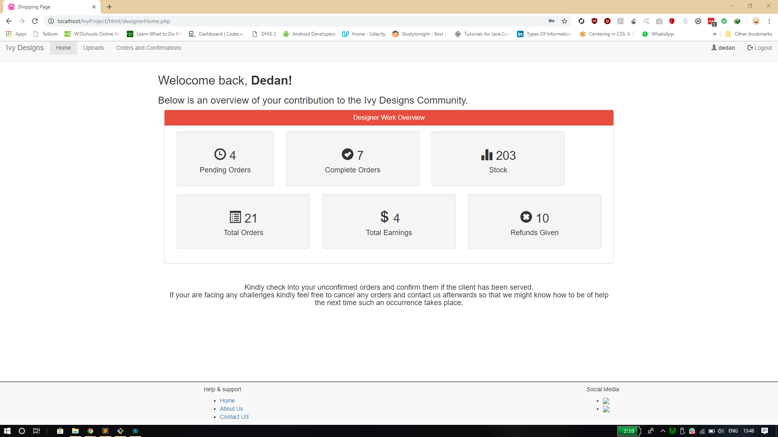

Designer home page

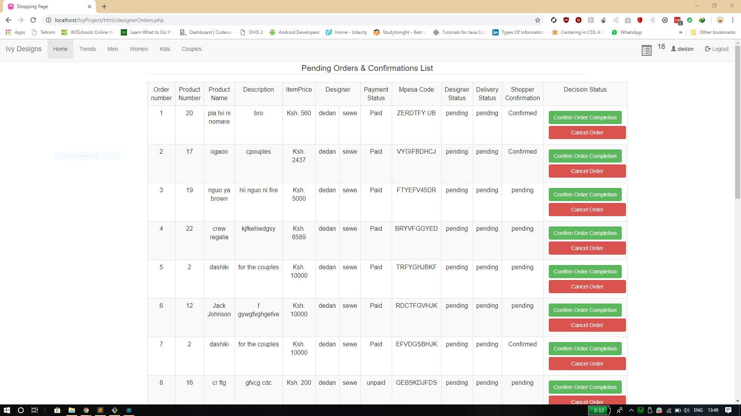

Designer order pages